* **Activity 2:**

Using Multiple Single Row Subqueries

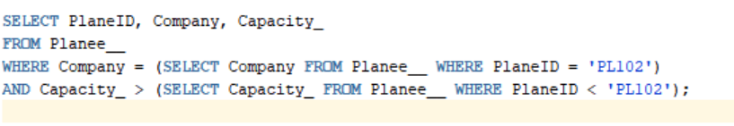

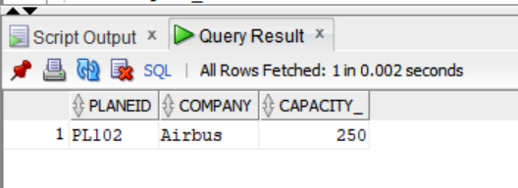OUTPUT: